**LAB 3**

**23K-0594**

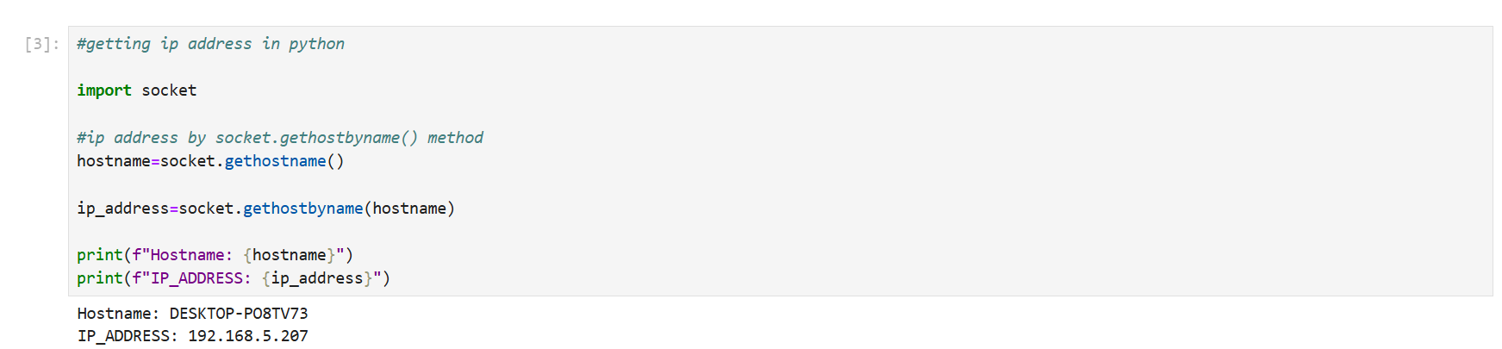

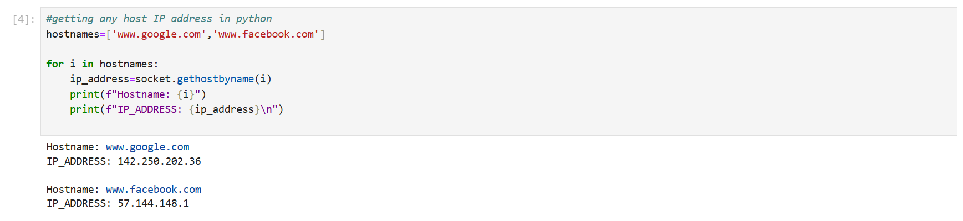

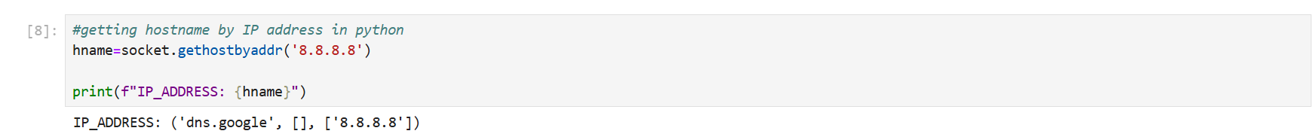

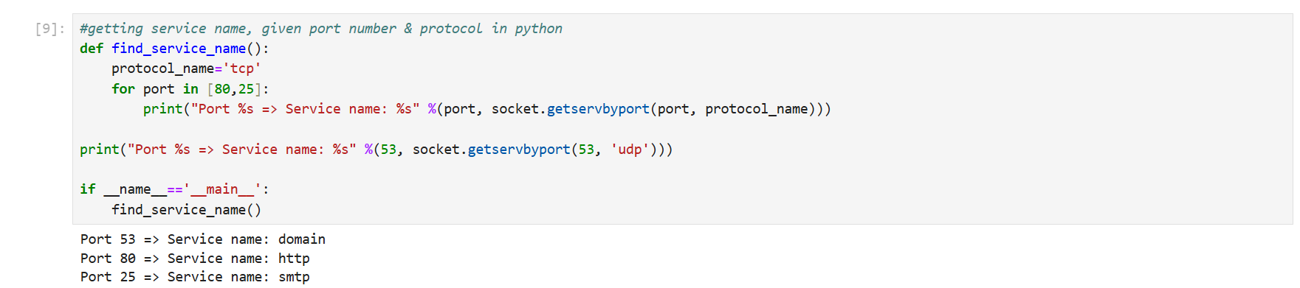

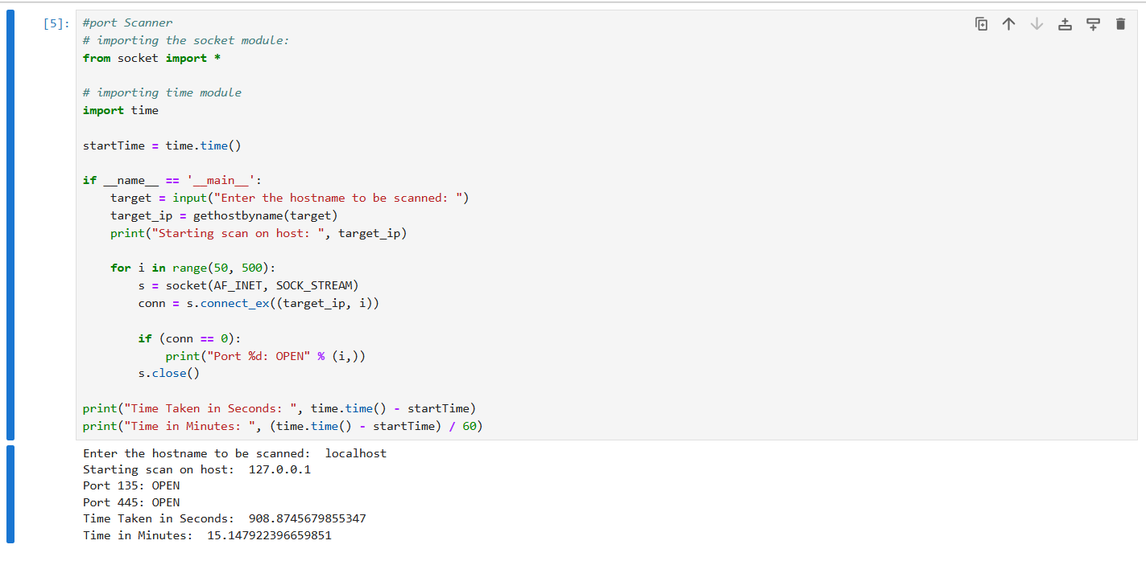

Client and server task 1:

